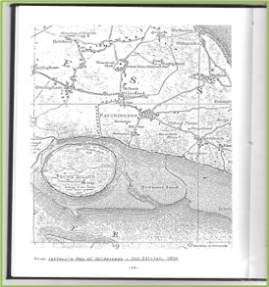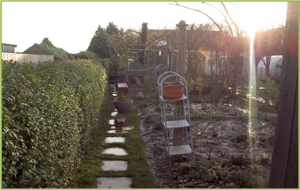

**AFTERNOON TALK**

***FLOODING IN THE HUMBERSIDE AREA:***

***History of flooding in the Humberside area***

***Historical geography of flooding***

***How to deal with flooding***

***The future***

**TUTOR**: ***Richard Clarke***

**DATE**: **Saturday, 27th July 2024**

**TIME: 2.00 pm to 4.30 pm** [doors open at 1.30]

**VENUE**: **Joseph Wright Hall,** next to the Wilderspin National School Museum, Queen Street, Barton upon Humber DN18 5QP

**FEE**: **£12.00** [including refreshments] - cash or cheque only please